NSS Activity Report: Blood Donation Camp
Date: 26.01.2020
A Blood Donation Camp was organised in ACVM campus in collaboration with Arpan Blood Bank, Jaipur on 26.01.2020 from 11:00 am onwards. Total 35 Units for blood was donated by the students and all the faculty members.
The donors were given certificates and a blood card so that they can take blood at time of need.
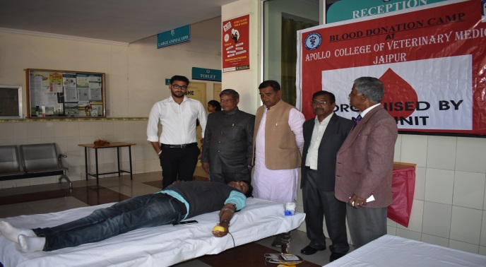 | 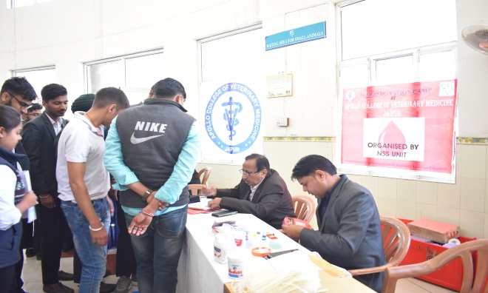
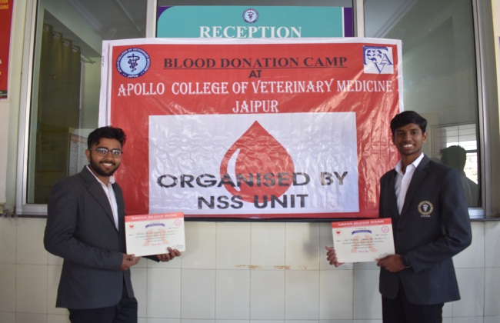 | 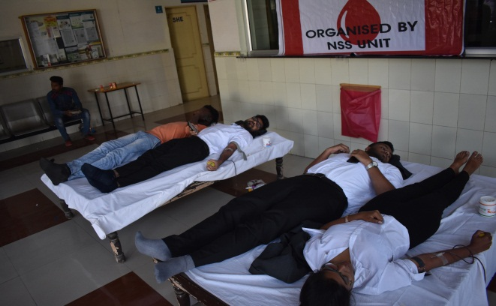

Dr.Selvam S.
Prof.&Head
Dept. of Vety.& A.H. Extension,
O/C NSS
ACVM, Jaipur

