NSS Activity Report: Swachh Bharat Abhiyaan (Campus Cleaning)
Date: 19.01.2019
Swachh Bharat Abhiyaan campaign was conducted in college campus on 19.01.2019 at 04:00 pm under NSS Activity. The programme started with the speech by Dean, ACVM, Jaipur Students of I and II year B. V. Sc. & A. H cleaned the various areas of college campus.
All the faculty members joined this campaign with students and helped in cleaning of the campus and picking up the empty wrappers, empty cans and unused items in the campus.

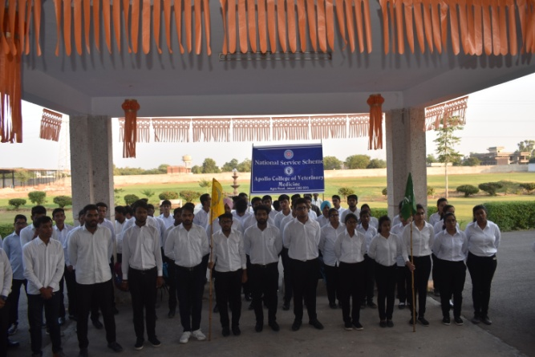 | 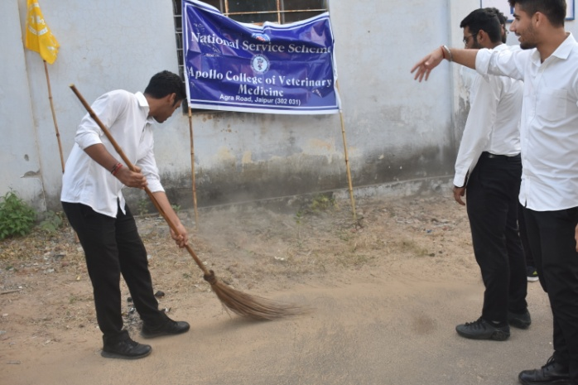
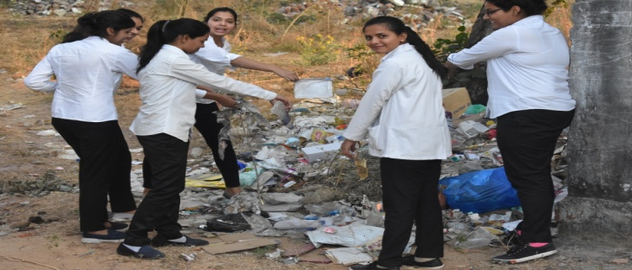 | 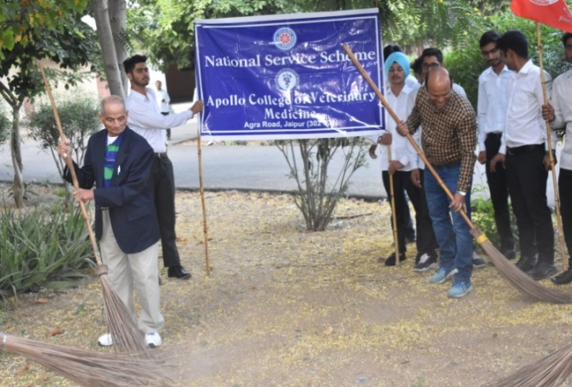

Dr.Selvam S.
Prof.&Head
Dept. of Vety.& A.H. Extension,
O/C NSS
ACVM, Jaipur

