NSS Activity Report: International Yoga Day
Date: 21.06.2019
International Yoga Day was celebrated in college campus on 21.06.2019 at 6:00AM as a NSS Activity. The celebration was started with the speech of Dean, ACVM; he said that the art of practicing Yoga helps in controlling an individual’s mind, body and soul. It also helps in increasing flexibility, muscle strength and body tone. All the faculty members and students of I year B. V. Sc & A. H. did various Assans under the instructions of the yoga instructor.

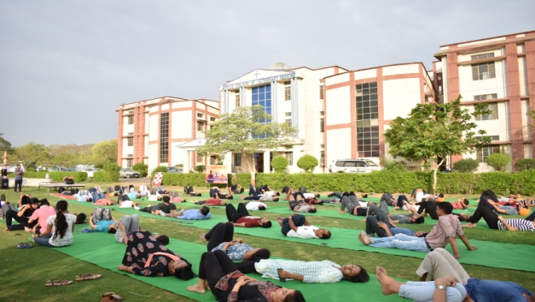 | 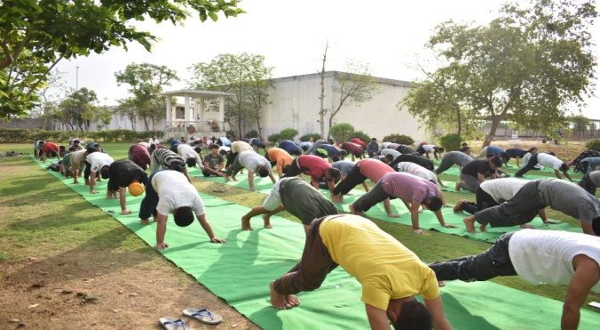
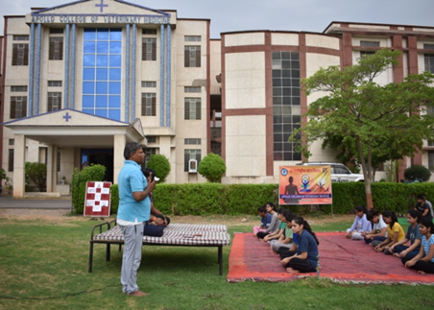 | 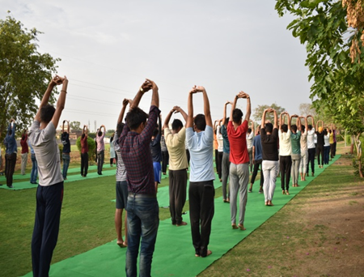

Dr.Selvam S.
Prof.&Head
Dept. of Vety.& A.H. Extension,
O/C NSS
ACVM, Jaipur

