NSS Activity Report: Tree Plantation Programme
Date: 28.09.2019
Tree plantation programme under NSS activities was conducted on 28.09.2019 at 3:00 pm in ACVM Campus. On this occasion all the faculty members and students of 2nd and 3rd year B.V. Sc &A. H. Participated. The programme included plantation of different varieties of plants in the campus.
Dr. C.S. Sharma, Dean of ACVM welcomed the participants and emphasise the importance of tree plantation in the human society and pointed that plants of different variety is important for our Earth Ecosystem. On this occasion all faculty members and students took interest and successfully participated in this programme.

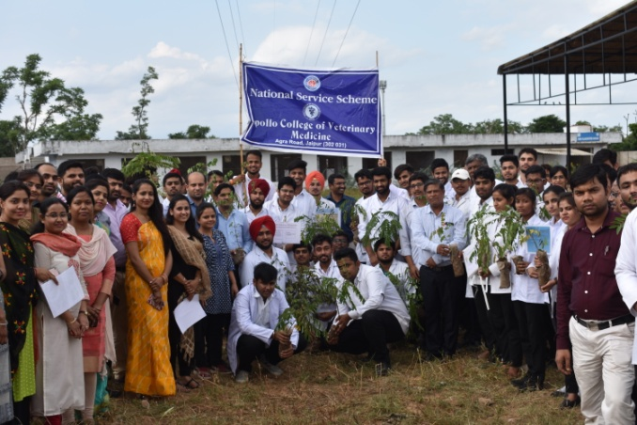 | 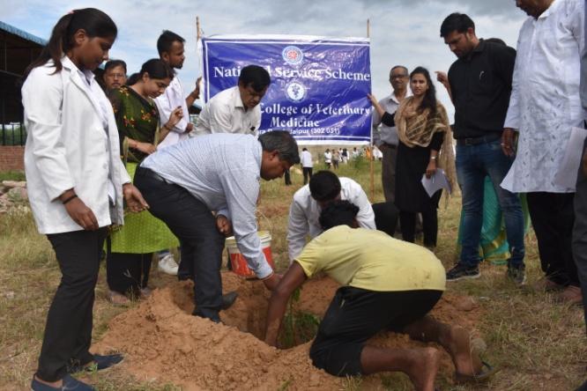
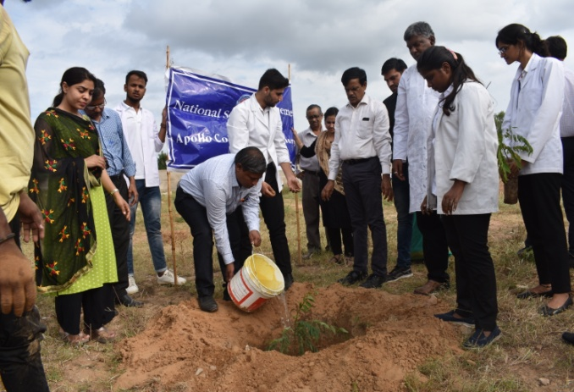 | 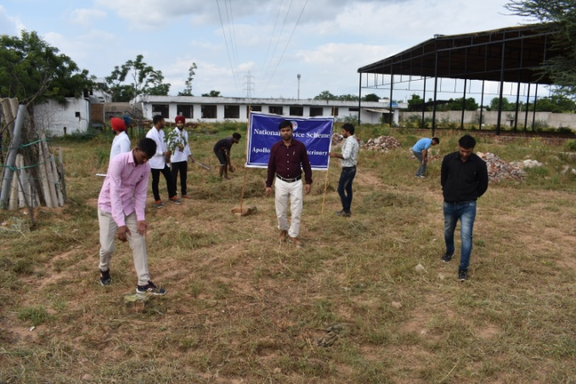

Dr.Selvam S.
Prof.&Head
Dept. of Vety.& A.H. Extension,
O/C NSS
ACVM, Jaipur

