NSS Activity Report: Republic Day Celebration
Date: 26.01.2020
NSS students and staff members celebrated Republic Day in college campus on 26.01.2020 at 8:00 AM. The programme started with welcome of chief guest and Flag Hoisting by the Dean and Trustee, ACVM, Jaipur. The Dean and Trustee gave a speech on importance of Republic Day to the students. On this occasion parade was performed by all the students of the ACVM and the teaching and non-teaching staff received award for the outstanding performance in the year 2019.

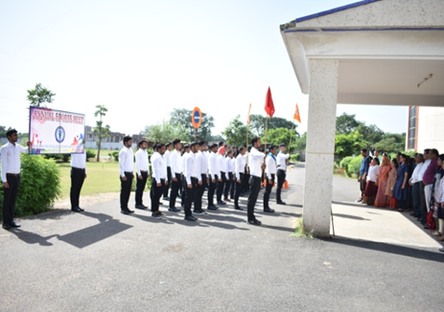 | 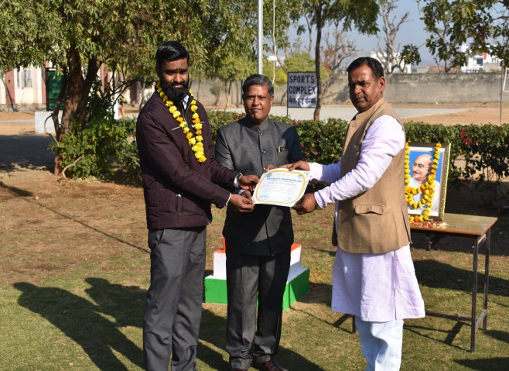
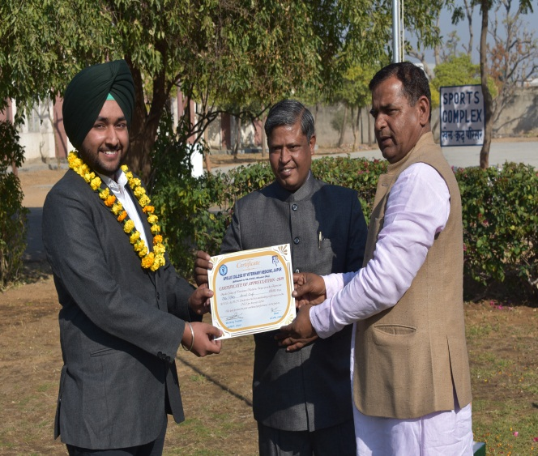 | 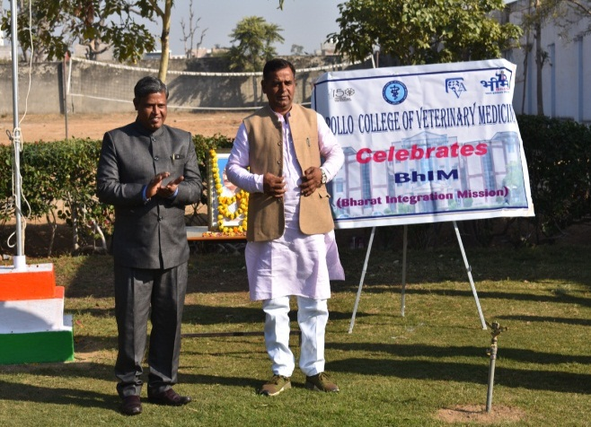

Dr.Selvam S.
Prof.&Head
Dept. of Vety.& A.H. Extension,
O/C NSS
ACVM, Jaipur

