Activity Report: Celebration of Swami Vivekananda Jayanti/ National Youth Day
Date: 12.01.2020

In reference to the mail received from Registrar, Rajasthan University of Veterinary and Animal Sciences, Bikaner vide F.No.(88)/RAJUVAS/Reg./Gen./2019/1066 Dated 26th December 2019, Apollo College of Veterinary Medicine celebrated Swami Vivekananda Jayanti/ National Youth Day on 12.01.2020 at 03:00 pm in the college premises.
Swami Vivekananda was born in Kolkata on January 12, 1863, as Narendra Nath Datta. He was one of India’s most revered spiritual leaders. It was in 1887 that he along with other disciples of Ramakrishna Paramhansa took formal vows of sannyasa and renounced the worldly pleasures. With a special interest in Western philosophy and history, he was often assailed by doubts about the existence of God. Through his speeches and lectures, Vivekananda tried to awaken the religious consciousness among people and also tried to uplift the downtrodden using the principles of practical Vedanta. The program was organized by the Department of Veterinary and Animal Husbandry Extension Education, ACVM, Jaipur. The celebration was started with welcoming the students and faculty members by the Dean, ACVM.
The Dean informed the gathering that India celebrates National Youth Day on January 12. This date was chosen to honor the birthday of Swami Vivekananda. He saw hope for the future in every child and believed that with “muscles of iron” and “nerves of steel” they could bring about social change. Swami himself personified the eternal energy of the youth and a restless quest for truth. Today, almost 50 percent of India’s population is under the age of 25. The future of the country rides on their shoulders — making celebrations that empower young people so important.
After the speech from Dean the students gave motivational speech from the speeches and lectures of Swami Vivekananda. The students contributed their views about Swami Vivekananda.
The students and faculty members were encouraged to follow the values of Swami Vivekananda. The program ended with National Anthem.

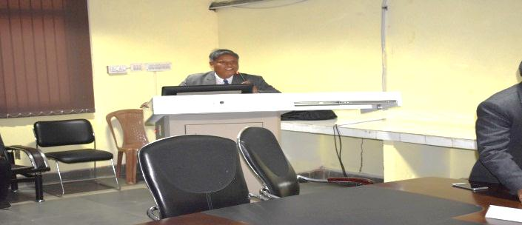 | 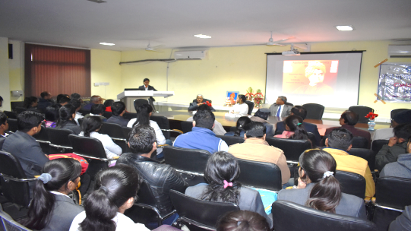
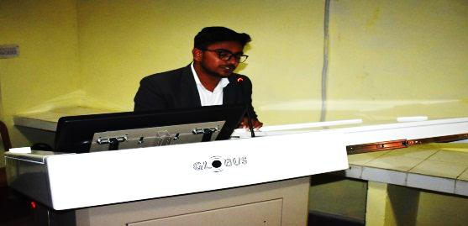 | 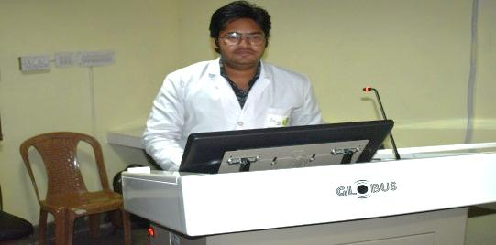

DEAN

