NSS Activity Report: Blood Donation Camp
Date: 20.04.2019
A Blood Donation Camp was organised in collaboration with Gem City Charitable Trust for two days i.e. 20.04.2019 from 2:00 pm onwards & on 21.04.2019 from 08:30 am onwards at Avedna Aashram Santokba Durlabhji Hospital (SDMH), Bapu Nagar, Jaipur. Eight NSS volunteers donated blood on this day at hospital. Total 20 students participated in the program.

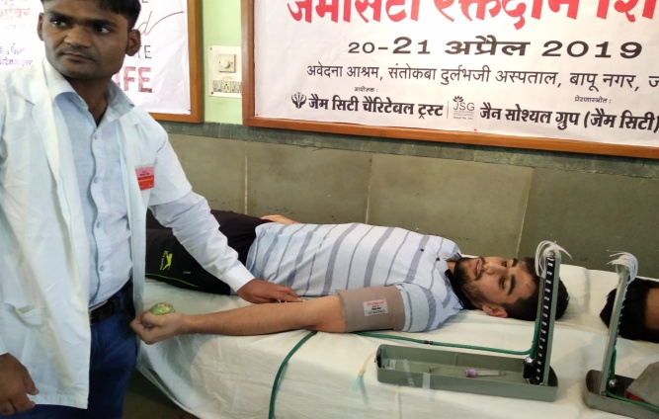 | 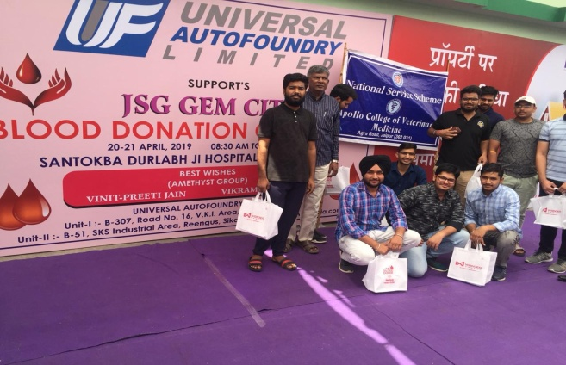
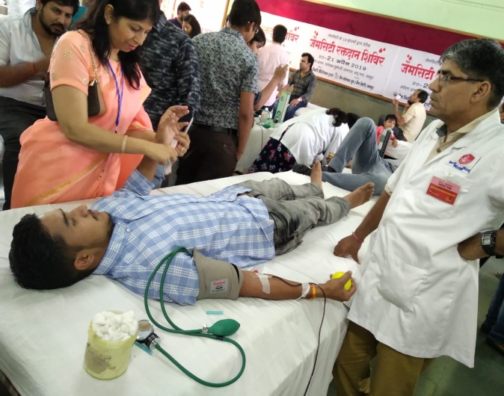 | 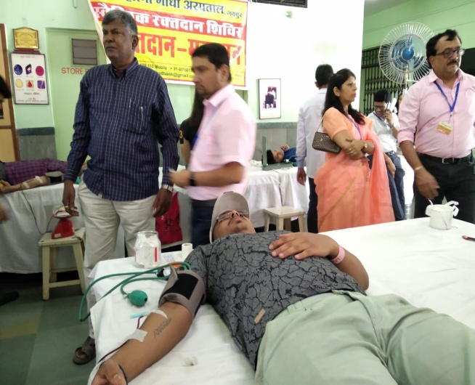

Dr.Selvam S.
Prof.&Head
Dept. of Vety.& A.H. Extension,
O/C NSS
ACVM, Jaipur

