Activity Report: Celebration of 70th Constitutional Day 2019
Date: 26.11.2019

A celebration of 70th constitution day was held in the ACVM campus on 26.11.2019. The program started with the speech of Dean Dr.C.S.Sharma and after that pledge was taken by the students and the faculty members.

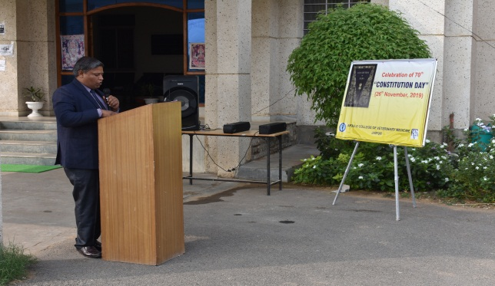 | 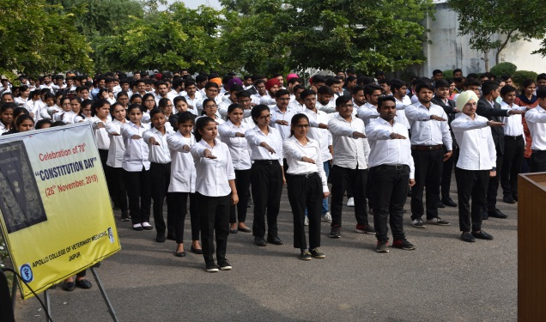
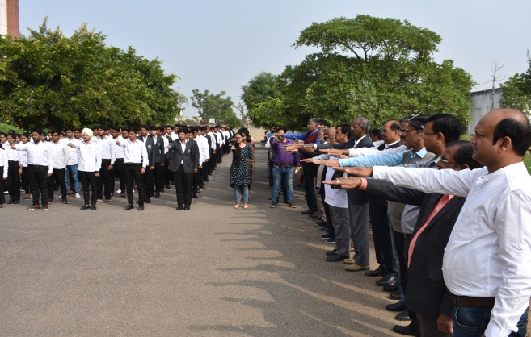 | 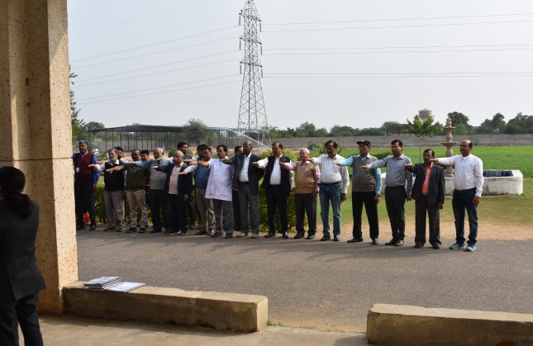

Dr.Selvam S.
Prof.&Head
Dept. of Vety.& A.H. Extension,
O/C NSS
ACVM, Jaipur

