NSS Activity Report:
Off-Campus Campaign

Date: 9.02.2019
An awareness program was organized by NSS Students at Jeetawala village, Jaipur on 09.02.2019. In this Campaign all the students of I and II year B. V. Sc & A. H. and the villagers actively participated and awareness was given for Dengue and Zika virus infection in human beings. On this occasion a rally was conducted in the village. Large animals in the village were vaccinated and the calves were dewormed free of cost.

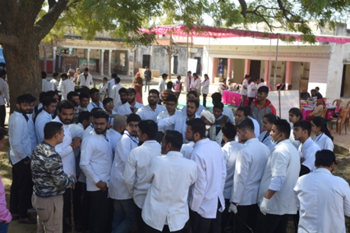 | 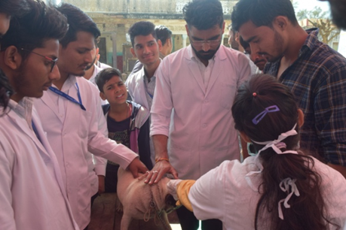
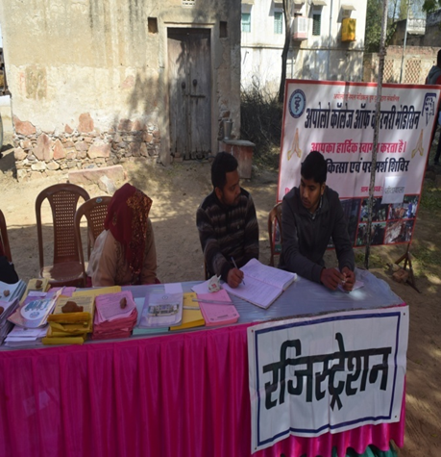 | 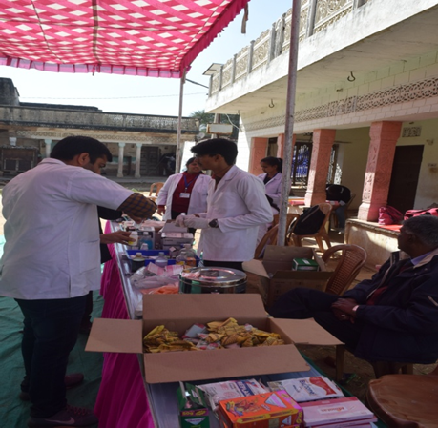

Dr.Selvam S.
Prof.&Head
Dept. of Vety.& A.H. Extension,
O/C NSS
ACVM, Jaipur

