NSS Activity Report: Poster Making Program
Date: 27.04.2019
A poster making competition for the first year and second year students was organised on the occasion of the celebration of World Veterinary Day 2019 on 27.04.2019. The students of the first year prepared the posters on Deworming of pet animals and second year students prepared the posters on vaccination of pet animals. First and second prize were distributed for the best poster presentation.

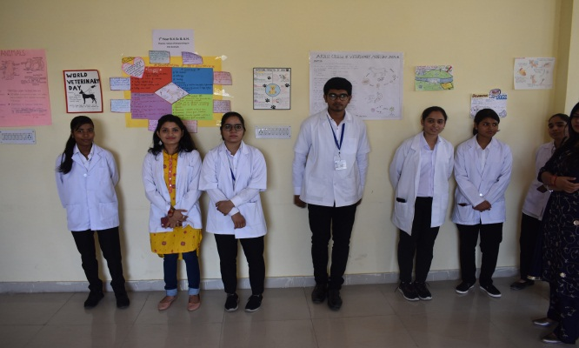 | 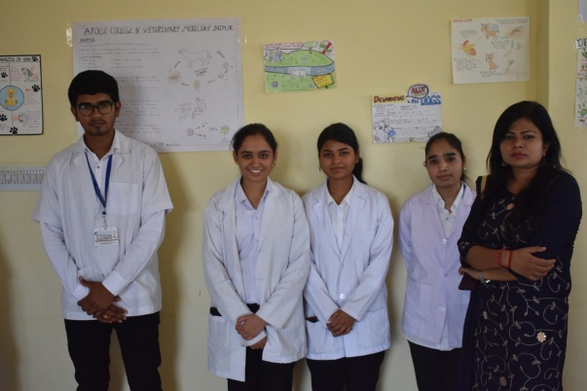
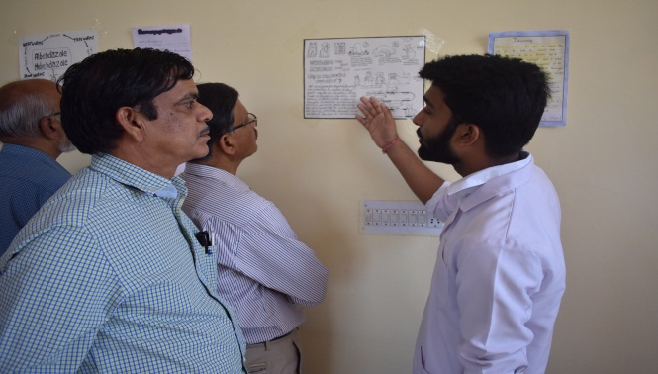 | 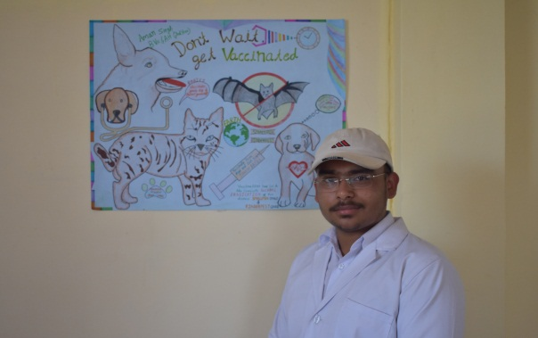

Dr.Selvam S.
Prof.&Head
Dept. of Vety.& A.H. Extension,
O/C NSS
ACVM, Jaipur

