NSS Activity Report: Republic Day Parade
Date: 26.01.2019
NSS students celebrated Republic Day in college campus on 26.01.2019 at 7:30 AM as a NSS Activity. The programme started with welcome of chief guest and Flag Hoisting by the Dean and Trustee, ACVM, Jaipur. The Dean and Trustee gave a speech on importance of Republic Day to the students. On this occasion parade was performed by all the students of the ACVM as NSS activity.

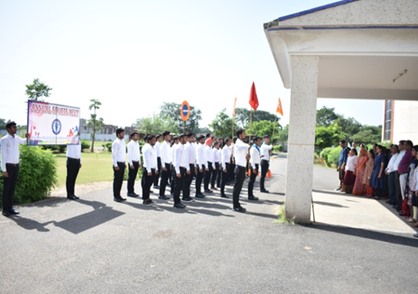 | 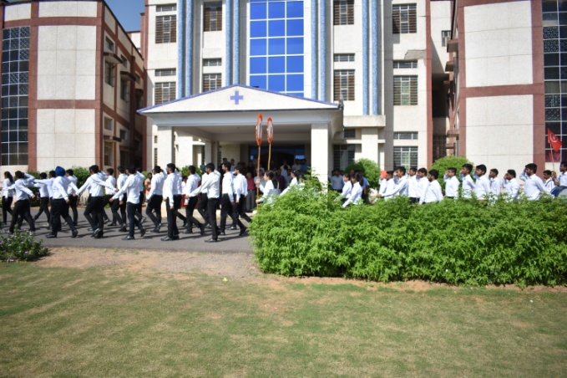
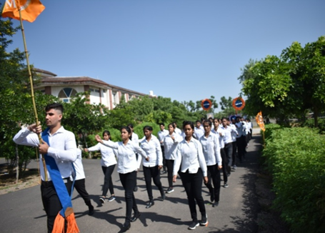 | 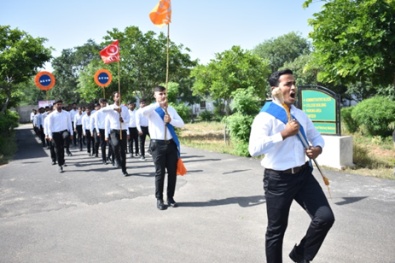

Dr.Selvam S.
Prof.&Head
Dept. of Vety.& A.H. Extension,
O/C NSS
ACVM, Jaipur

