NSS Activity Report: Swachh Bharat Abhiyaan
(Sports Ground Cleaning)

Date: 01.02.2019
Swachh Bharat Abhiyaan campaign was conducted in college campus on 01.02.2019 at 04:00 PM under NSS Activity. The programme started with the speech by Dean, ACVM, Jaipur. The students of I and II year B. V. Sc & A. H cleaned the playgrounds.
The students cleaned the Basketball and Volleyball Court by picking up all the wastes on ground.

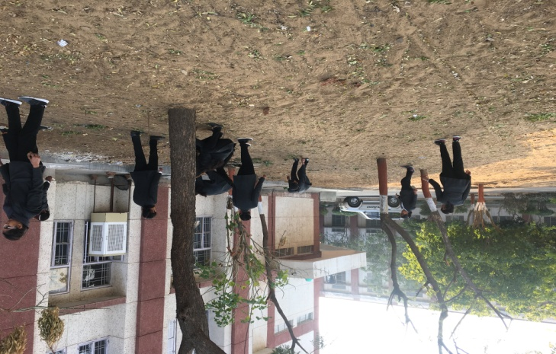 | 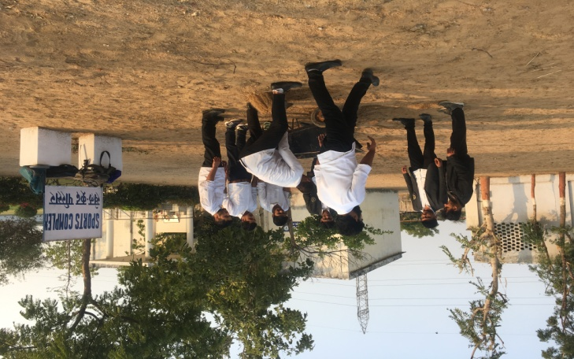

Dr.Selvam S.
Prof.&Head
Dept. of Vety.& A.H. Extension,
O/C NSS
ACVM, Jaipur

