Activity Report: Visit to Animal Fair –Pushkar, Rajasthan
Date: 09.11.2019
A visit to Animal Fair at Pushkar, Rajasthan was organised on 09.11.2019. All the students of B.V.Sc. & A.H. - III year went for this activity along with the Faculty Members. The main purpose for the visit was to give exposure to the students about farm animals and their breeds, marketing channels of various animals and constraints faced by the animal owners.
A Schedule was also prepared for the students so that they can interact with the owners and fill the detailed information about various aspects.

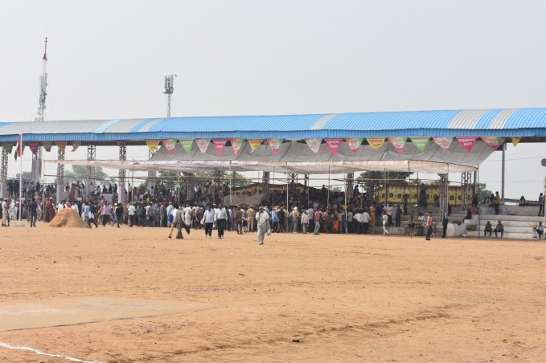 | 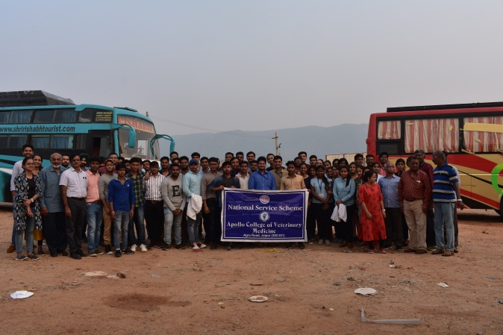
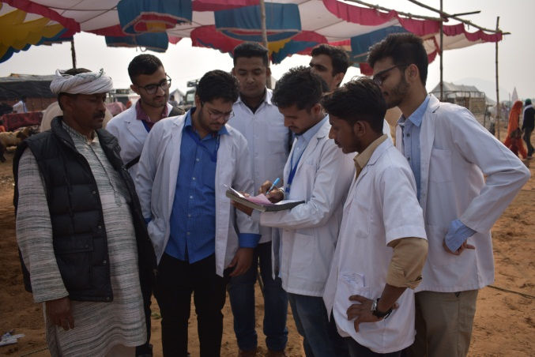 | 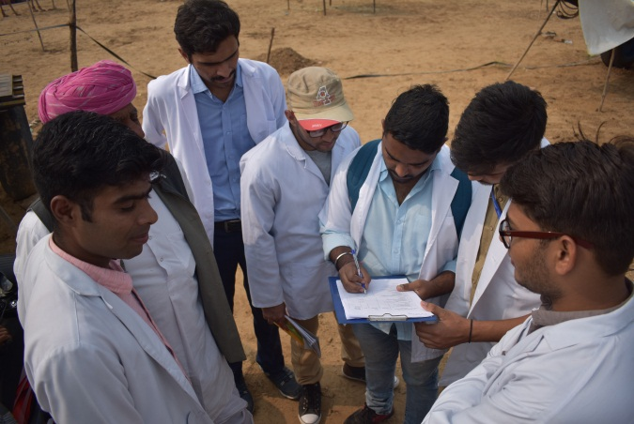

Dr.Selvam S.
Prof.&Head
Dept. of Vety.& A.H. Extension,
O/C NSS
ACVM, Jaipur

